Cooling observations
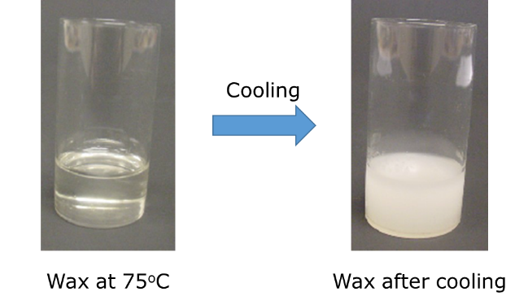
1. Candles are made from wax.
When wax is very hot it is a liquid.
As liquid wax cools it can solidify
and turn into a solid.

The melting point of wax is 67ºC.
At what temperature does wax start to solidify?
A 69°C
B 67°C
C 65°C
D Around 40°C

2. Lead is a type of metal.
When lead is very hot it is a liquid.
As liquid lead cools it can solidify and turn into a solid.
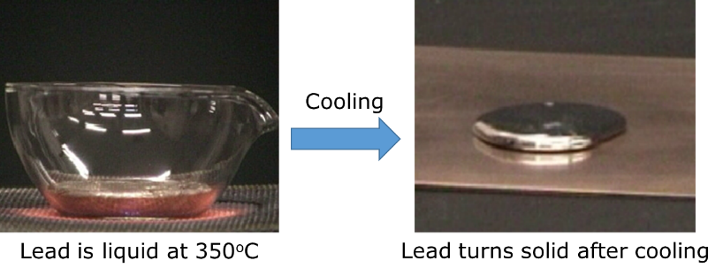
The liquid lead starts to solidify at 327ºC.
What is the temperature of lead when the last bit has turned solid?
A 327°C
B 326°C
C 325°C
D Around 320°C
Chemistry > Big idea CSU: Substances and properties > Topic CSU1: Substance and mixtures > Key concept CSU1.1: Substance
Diagnostic question
Cooling observations

Overview
Learning focus: | A chemical substance has a characteristic melting and boiling point and can exist in different states.
Observable learning outcome: | Match observations of melting (or cooling) to the temperature at which they take place.
Question type: | Simple multiple choice
Key words: | solid, liquid, state, melting point, temperature

What does the research say?
Johnson and Papageorgiou (2010) used questions to explore students understanding of macroscopic observations of melting in relation to melting point. Students with a sound understanding understood that melting point was the divide between the solid and liquid states and that a substance would show no signs of melting below the melting point (or of solidifying above this temperature whilst cooling).
However, some students considered melting point to be the start or end of a narrow zone over which melting or solidification occurred.
A third group of students did not recognise that melting point is the same as the temperature at which solidification (freezing) occurs. Even though the term solidification was used in the question (to avoid everyday associations with ‘freezing’) students still thought that solidification would occur well below the melting point.
Ways to use this question
Students should complete the question individually. This could be a pencil and paper exercise, or you could use an electronic ‘voting system’ or mini white boards and the PowerPoint presentation.
The answers to the question will show you whether students understood the concept sufficiently well to apply it correctly.
If there is a range of answers, you may choose to respond through structured class discussion. Ask one student to explain why they gave the answer they did; ask another student to explain why they agree with them; ask another to explain why they disagree, and so on. This sort of discussion gives students the opportunity to explore their thinking and for you to really understand their learning needs.
Expected answers
1 B 2A

How to respond - what next?
In these questions the word ‘solidification’ has been included to avoid confusion as students may associate freezing with the formation of ice at 0°C.
For question 1, selection of answer A suggests that the student thinks that freezing (solidification) will occur during cooling before the melting point is reached. This could indicate that the student thinks that solidification happens over a range of temperatures. Selection of C or D, which are below the melting point, indicates that the student does not recognise that freezing (solidification) happens at the same temperature as melting.
For question 2 selection of B, C or D implies that the student thinks that freezing (solidification) either occurs at a different temperature to melting or that it happens over a range of temperatures.
A good response to finding a misunderstanding, could be to teach the idea to the class and then give the students an activity in which they can practise using the concept so that they can consolidate their understanding. Responses often work best when the activities involve paired or small group discussions, which encourage social construction of new ideas through dialogue.
If students have misunderstandings about melting (or freezing) happening at a substance’s melting point. The following BEST ‘response activity’ could be used in follow-up to this diagnostic question:
- Comparing melting
Acknowledgments
Developed by Helen Harden (UYSEG), from a York Science question devised by Andrew Hunt.
The questions were selected from a collection of ASK questions devised for research by Philip Johnson.
Images: Philip Johnson.
References
Johnson, P. and Papageorgiou, G. (2010). Rethinking the Introduction of Particle Theory: A Substance-based framework. Journal of Research in Science Teaching. 42(2) 130-150
Johnson, P. (2012). Introducing particle theory. In Taber, K. (ed.) ASE Science Practice: Teaching Secondary Chemistry. New edition ed. London: Hodder Education.

